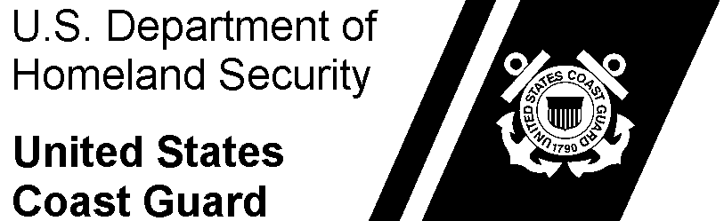 | Commander  U.S. Coast Guard  Unit Name | Staff Symbol:  Phone:  Fax:  Email:

5814
03 Feb 2019
MEMORANDUM
From: | Reviewing JAG’s Name Here, Rank, USCG  Judge Advocate
To: | The Office of Military Justice (CG-LMJ)
Subj: | JUDGE ADVOCATE REVIEW UNDER R.C.M. 1201 IN THE SPECIAL [GENERAL] COURT-MARTIAL CASE OF UNITED STATES v. ACCUSED’S NAME HERE
Ref: | - Article 65(d), Uniform Code of Military Justice (UCMJ).  - Rules for Courts-Martial (R.C.M.) 1201.
- Per R.C.M. 1201(a)(1), I reviewed the attached record of trial in the special [general] court-martial case of United States v. Accused Name, USCG.
- Pursuant to R.C.M. 1201(d) and based on my review of the record I conclude that:
  - The court-martial had jurisdiction over the accused and the offenses as to which there is a finding of guilty;
  - The charge and specification(s) as to which there is a finding of guilty state an offense under the UCMJ.
  - The sentence approved by the Convening Authority was within the limits prescribed by law.
- The accused did not submit any matters alleging error. Accordingly, the response required by R.C.M. 1201(d)(4) is unnecessary in this case.
#

